**Documentation:**

**Lineage Graph**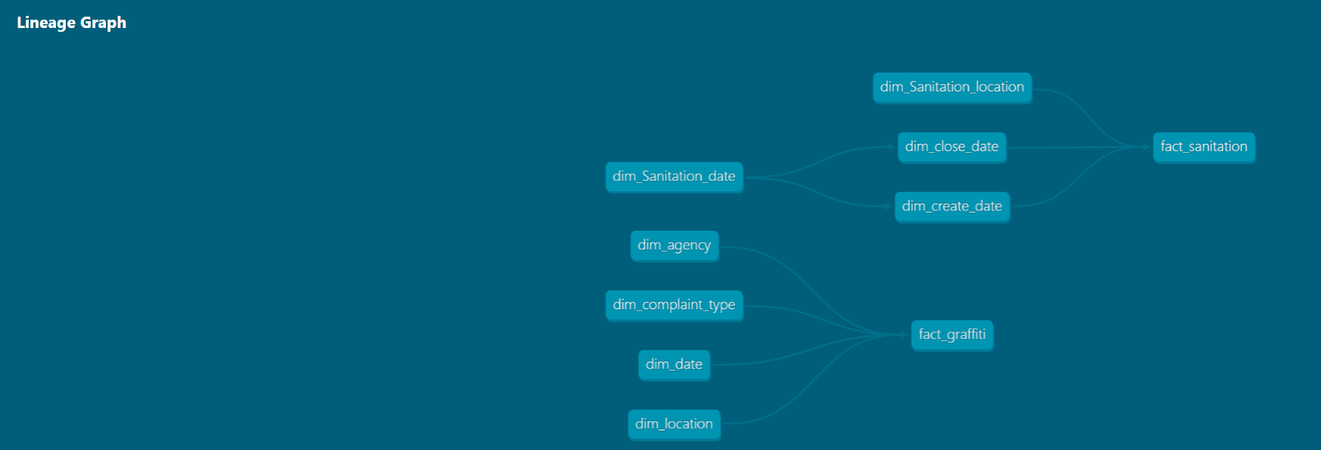

### 

### 

### 

### **1. Data Ingestion:**

* **Source Data Loading:** We successfully loaded our source datasets (Graffiti and Sanitation) into BigQuery.
* **dbt Project Setup:** We linked our dbt project to your BigQuery project using a service account key. This connection allows dbt to interact with your data and execute SQL transformations.

### **2. Data Modeling and Transformation:**

* **Model Creation:** We defined data models (dimensions and facts) for both Graffiti and Sanitation data. These models outline the structure and relationships between different data elements.
* **SQL Queries:** We wrote the SQL queries within these models to transform and clean the raw data, creating a data warehouse-ready structure.

Fact Graffiti

SQL Query:

{{ config(

materialized='view'

) }}

SELECT

`Unique Key` AS unique_key,

d.date_dimension_id,

a.agency_dim_id,

ct.complain_dim_type_id,

l.location_dim_id,

COUNT(*) AS complaint_count

FROM

`cis9440finalproject-442001.source_dataset.grafitti_complaints_dataset` c

JOIN {{ ref('dim_date') }} d ON c.`Created Date` = TIMESTAMP(d.full_date)

JOIN {{ ref('dim_agency') }} a ON c.Agency = a.agency_name

JOIN {{ ref('dim_complaint_type') }} ct ON CONCAT(c.`Complaint Type`, '_', c.`Descriptor`) = ct.complain_dim_type_id

JOIN {{ ref('dim_location') }} l ON CONCAT(c.`Location Type`, '_', c.`Incident Zip`, '_', c.`Borough`) = l.location_dim_id

GROUP BY

unique_key, d.date_dimension_id, a.agency_dim_id, ct.complain_dim_type_id, l.location_dim_id

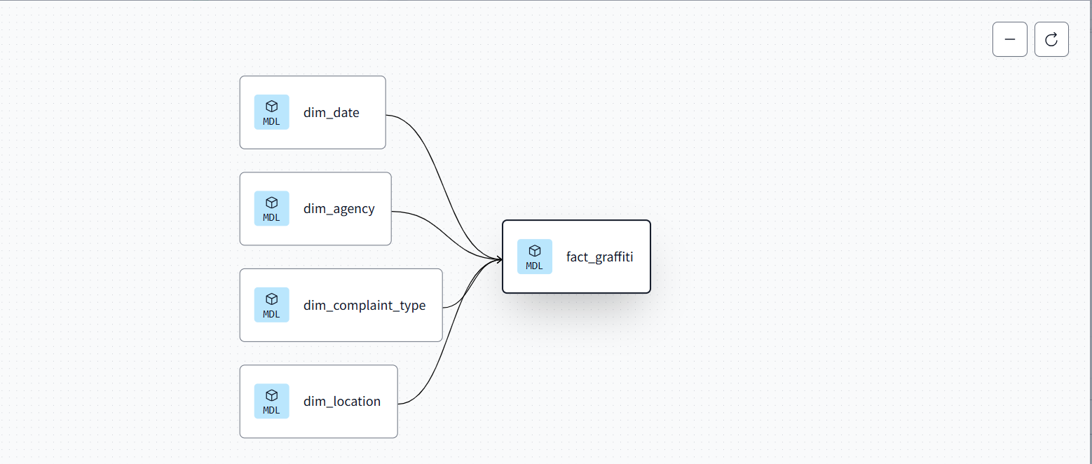

Fact Sanitation

SQL Query:

WITH base_data AS (

SELECT

BID_Name,

Borough,

`Incident Address`,

CONCAT(`BID_Name`, '_', `Borough`, '_', `Incident Address`) AS location_dim_id,

SAFE_CAST(`Sanitation Staff Employed` AS INT64) AS sanitation_worker_employed,

SAFE_CAST(`Public Safety Employed` AS INT64) AS public_safety_officers_employed,

SAFE_CAST(`Sanitation hours Worked` AS FLOAT64) AS sanitation_hours_worked,

SAFE_CAST(`Public Safety Hours Worked` AS FLOAT64) AS public_safety_hour_worked,

SAFE_CAST(`Trash Bags Collected` AS INT64) AS trash_collected,

SAFE_CAST(`Trash Receptacles Services` AS INT64) AS trash_and_recycling_receptacles,

SAFE_CAST(`Graffiti Incidents Removed` AS INT64) AS incidents_graffiti_removal,

SAFE_CAST(`Sanitation Expenses` AS FLOAT64) AS sanitation_expenses,

SAFE_CAST(`Public Safety Expenses` AS FLOAT64) AS public_safety_expenses,

PARSE_DATE('%Y-%m-%d', FORMAT_DATETIME('%Y-%m-%d', `Incident Date`)) AS create_date_id,

PARSE_DATE('%Y-%m-%d', FORMAT_DATETIME('%Y-%m-%d', `Resolution Update Action Date`)) AS close_date_id

FROM

`cis9440finalproject-442001.source_dataset.bid_trends_sanitation`

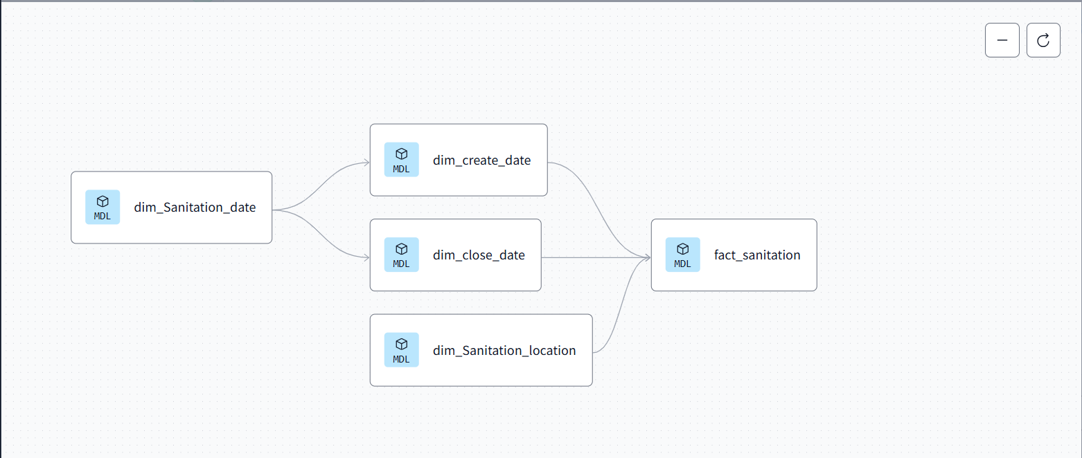

### 

### 

### **3. Testing and Deployment:**

* **Testing:** We set up a testing environment to run tests on our models, ensuring data quality and consistency.
* **Deployment:** Once testing was successful, we deployed our dbt project to production, triggering the execution of the defined transformations.

**Testing Query:**

version: 2

models:

- name: stg_agency

description: Staging model for containing agency-related information

columns:

- name: agency_dim_id

description: Unique identifier for an agency

tests:

- unique

- not_null

- name: stg_complaint_type

description: Staging model for storing the type of complaints

columns:

- name: complain_dim_type_id

description: Unique identifier for a complaint type

tests:

- unique

- not_null

- name: stg_date

description: Staging model for date dimension

columns:

- name: date_dimension_id

description: Unique identifier for the date dimension

tests:

- unique

- not_null

- name: stg_location

description: Staging model for location dimensions

columns:

- name: location_dim_id

description: Unique identifier for the location dimension

tests:

- unique

- not_null

- name: stg_Sanitation_date

description: Staging model for the sanitation date dimension

columns:

- name: date_dimension_id

description: Unique identifier for sanitation date

tests:

- unique

- not_null

- name: stg_Sanitation_location

description: Staging model for sanitation location dimensions

columns:

- name: location_dim_id

description: Unique identifier for sanitation locations

tests:

- unique

- not_null

- name: stg_close_date

description: Staging model for sanitation close dates

columns:

- name: closed_date_id

description: Unique identifier for close dates in sanitation

tests:

- unique

- not_null

- name: stg_create_date

description: Staging model for sanitation creation dates

columns:

- name: created_date_id

description: Unique identifier for create date in sanitation

tests:

- unique

- not_null

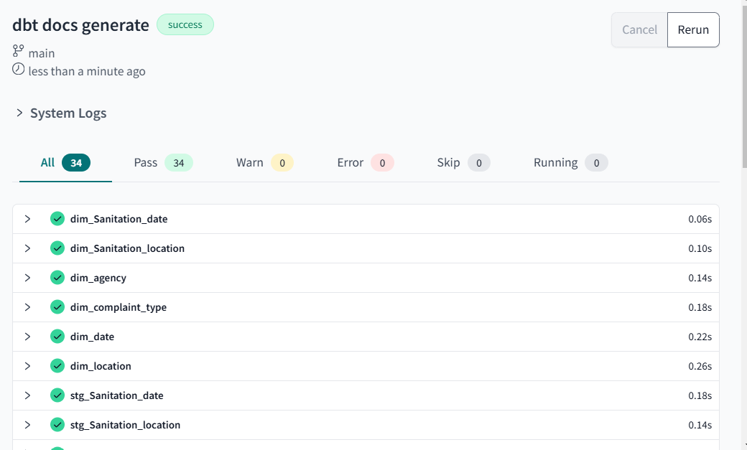

**Deployment:**

